South River City Citizens Neighborhood Association Neighborhood News

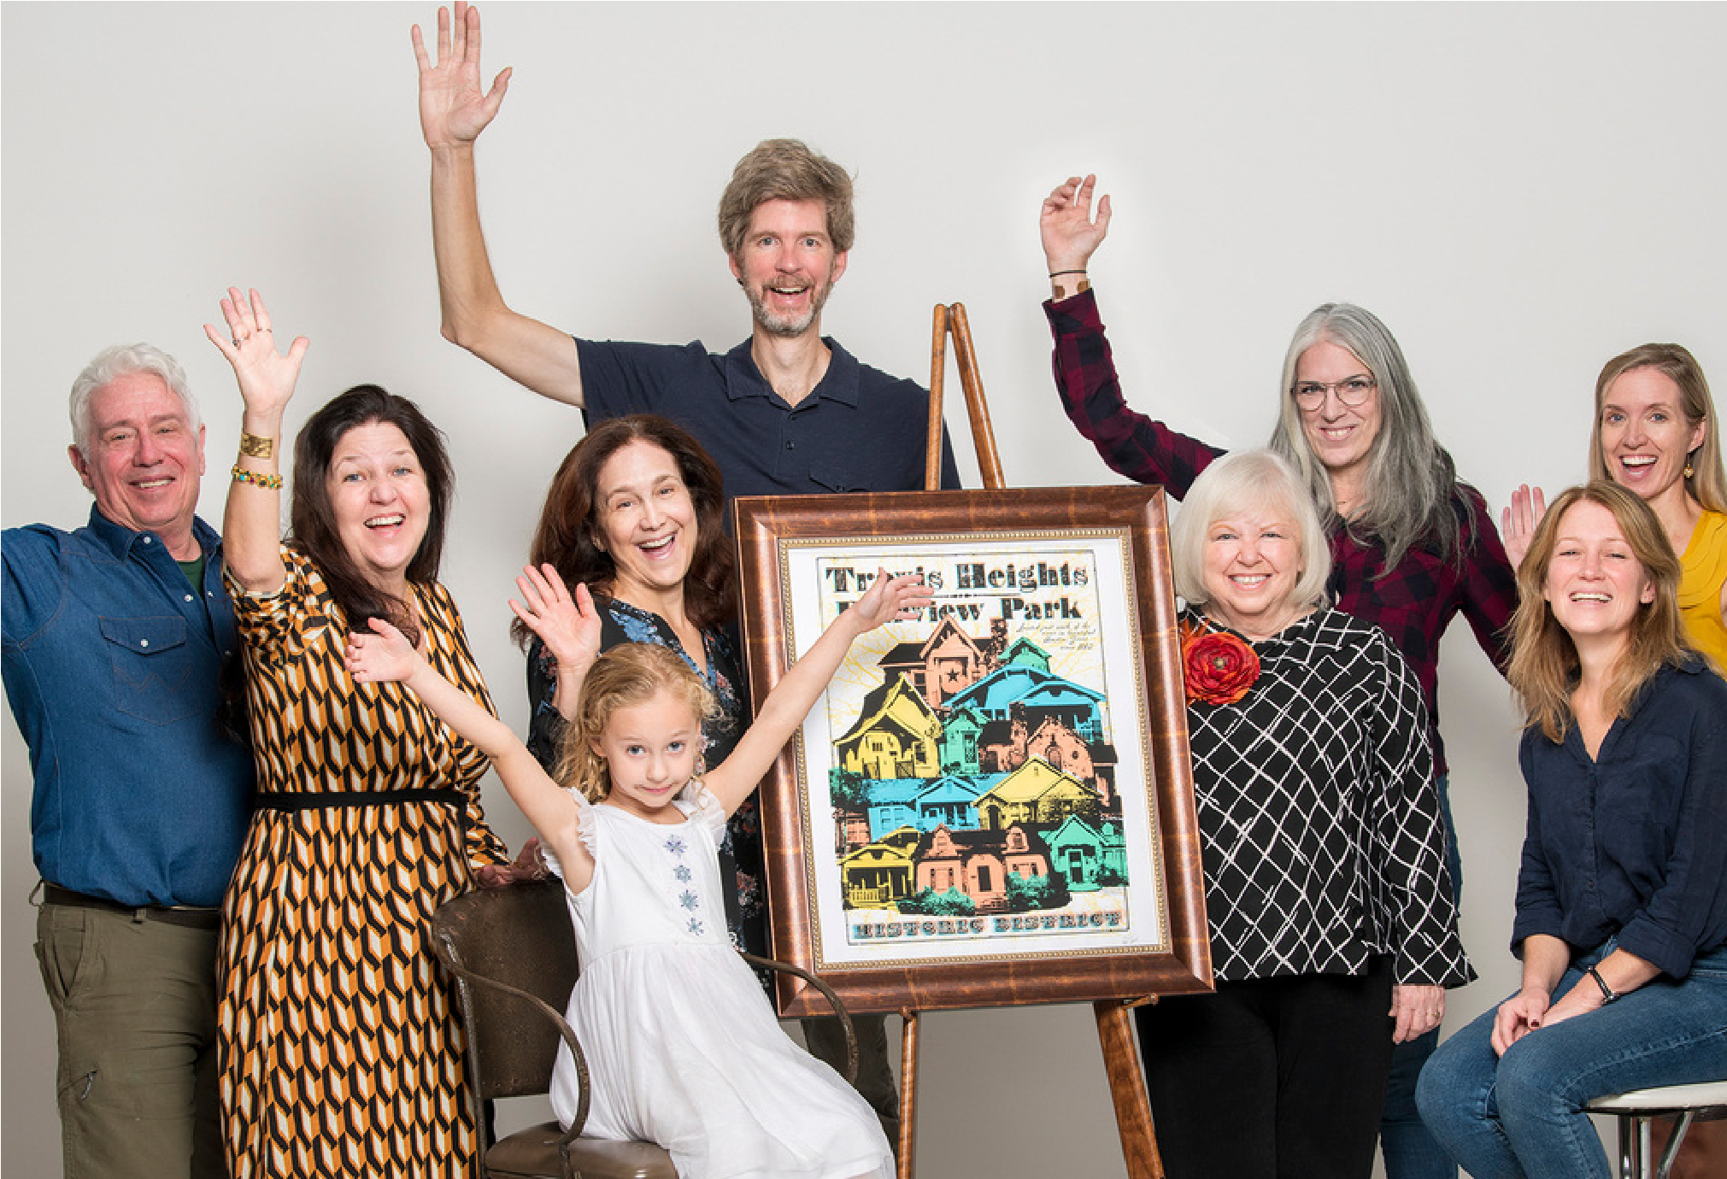

Est. 1973 | April 2022

From left to right, committee members: Clifton Ladd, Paula Kothmann, Michele Webre, Bob Gee, Terri Myers, Melanie Martinez, Angela Reed, Susan Armstrong Fisher, with honorary member seated on left, Leila Gee (Bob’s daughter). Photo courtesy of Brenda Ladd Photography.

Travis HeightsFairview Park

Neighborhood Confirmed as

# National Register Historic District

This past fall, 2021, we celebrated as the Travis HeightsFairview Park Neighborhood was confirmed as a National Register Historic District and listed with the National Park Service. This accomplishment is the culmination of a years-long project that began in 2004 when a few dedicated SRCC neighbors acted to preserve our neighborhood by applying for its recognition as a historic district. There were dozens of volunteers as well as a handful of hired consultants who worked diligently to gather historical evidence, location data for each house, occupancy records, and photos to support the

1

application. There were times when it appeared the project was dead because of time and monetary constraints, but the stalwarts did NOT give up. They persevered, recruiting more folks who offered their time and donations, and the work continued. Finally, with help from many neighbors, the designation was realized! Special thanks are due to the following: Michele Webre and Melanie Martinez who started the project and

*(continued)*

stuck with it through to the end, offering countless volunteer hours to the project; Preservation Austin which provided grant funds and advocacy for the district; and Terri Myers, Preservation Consultant with Preservation, Inc. who thoroughly researched the neighborhood, compiled the 267-page nomination, and presented it to the State Board of Review and the National Park Service. But make no mistake – the Travis Heights-Fairview Park Historic District was supported by hundreds of neighborhood residents who held fundraisers, wrote letters to save our historic houses, spent long hours at Commission and Council meetings, met with homeowners, prepared photos and documentation, and donated to the cause. Without everyone’s support, having the neighborhood recognized as a National Historic District would not have succeeded. This project was a labor of love by its residents and is now the largest residential National Register District in Austin. The Travis Heights-Fairview Historic District is comprised solely of residential homes and is approximately 353 acres, with boundaries roughly as follows:

From the south bank of Lady Bird Lake, just above Edgecliff Terrace on the North to E. Live Oak Street on the South; and

From the rear property lines on the east side of Kenwood Avenue on the East, to the Rear

(eastern) lot lines of S. Congress Avenue, on the West

The application required a survey of all structures within the boundaries; buildings that were at least 50 years old and retained the majority of their historic integrity were considered “contributing,” but all buildings, new and old, were included in the survey. You may view the latest draft of the nomination that was submitted to the State Board of Review to read the history of the district, and see photos of representative historic structures. You may also look up your house to see if it is considered “contributing,” by going to the Texas Historical Commission’s website: [thc.texas.gov/public/upload/preserve/national_register /draft_nominations/Travis%20HeightsFairview%20Park%20Historic%20District%20SBR%20D raft.pdf%20 (the nomination will be searchable on the](https://www.thc.texas.gov/public/upload/preserve/national_register/draft_nominations/Travis%20Heights-Fairview%20Park%20Historic%20District%20SBR%20Draft.pdf%20) National Park Service’s website at a later date, here:

[nps.gov/subjects/nationalregister/databaseresearch.htm)](https://www.nps.gov/subjects/nationalregister/database-research.htm)

it does serve to slow things down a bit so that homeowners can be educated about historic architectural styles in the neighborhood, and how they might modify their contributing home in a way that is sensitive to its history. The City of Austin Historic Landmark Commission (Commission) may delay a demolition of a contributing structure by several months so the owner may be informed and become aware of the historic status, and the Commission may consult with the homeowner about suggested guidelines for alternatives to demolitions and alterations so that perhaps choices can be made to maintain its contributing status. The designation also comes with some benefits. If a property is contributing to the district and is income-producing, then the owner may be eligible for tax credits when renovating the building, which ultimately can make rentals more affordable. More about that on the THC's website, [HERE.](https://www.thc.texas.gov/preserve/projects-and-programs/preservation-tax-incentives/texas-historic-preservation-tax-credit) Most of all, the designation communicates that this place matters to its residents and to the overall history and identity of our city, and that it is worthy of preservation.

- Angela Reed Historic Preservation Committee

# Zilker Park Rewilding

As Austin grows, much of Zilker Park is being loved to death. The city Parks Department has asked for public input for reimagining the park. In response, neighborhoods in south Austin have proposed a detailed plan for fixing much of the damage by reintroducing more of the natural environment. They call for “rewilding” some areas and making other areas that are underutilized more available to the public. The proposal includes adding more trees for shade, putting vegetation in areas that are little more than dirt, and fixing areas that suffer from extreme erosion. A full description of the rewilding plan can be found at srccatx.org/wp-content/uploads/2022/01/Rewilding_ Zilker.pdf.

The SRCC will be voting on whether or not to join neighborhood associations from Zilker, Bouldin Creek, and Barton Hills in supporting this proposal at the general membership meeting on April 19th.

|  |
| --- |
| So why is this designation important? People may ask whether this nomination will prevent tear-downs, or prevent someone from altering their house. The district has no zoning authority to do either. However, |

- Betty Weed

## A Note from the SRCC President

South River City Citizens Neighborhood Association is celebrating its fiftieth anniversary this year. Our volunteer-run, membership-based, community group can now look back on five decades of neighbors fulfilling the mission to improve and protect our quality of life. Since inception, SRCC has focused on issues of land use, zoning, schools, roads, parks and pools. Our advocacy involves knocking on doors, attending meetings, writing letters, making calls, negotiating with developers, coordinating with the city, and helping one another. SRCC invites you to our upcoming meeting (April 19th) so that we can meet you and work together as good citizens and better neighbors.

- Wendy Price Todd

# Report from Area 7

SRCC Area 7 includes the area east of I-35 to Parker Lane and from Woodland to Oltorf and is the westernmost portion of East Riverside Oltorf Combined (EROC), which encompasses a much greater area, i.e., east to Grove Street and between the south shore of Lady Bird Lake and Ben White Blvd. EROC fundamentally differs from the SRCC/Travis Heights area with more culturally and economically diverse residents, more multi-family complexes, and less developed park and recreation areas. Two important issues have arisen adjacent to Area 7 that are worthy of discussion.

**Issue:** Rezoning of former United Methodist Church, 2111 Parker Lane. In 2021, the EROC opposed the rezoning of the United Methodist Church property, located at 2111 Parker Lane, to become a multi-family apartment complex. EROC urged the property to remain Civic use as indicated on the Future Land Use Map (FLUM), with the hope that the site would be converted into neighborhood recreation/civic use, such as a community center with adjacent parkland.

However, due to the church’s decision and recommendations by it and others, the City approved the zoning change and agreed to allow Foundation Communities, a non-profit organization, to develop the property into an affordable multi-family complex. Going forward, efforts will continue with the developer in order to obtain benefits and connectivity, e.g., green space, playscapes, etc. for all SRCC Area 7 neighbors and EROC residents.

**Issue:** Proposed closure of Woodland Avenue at IH

35. EROC residents are concerned about the

proposed closure of Woodland Avenue as part of the Capital Express Central Project. Closing that important east-west thoroughfare would adversely impact neighbors who use the highway underpass to access work and schools, parks and pools as well as shopping. In addition, police, fire and emergency vehicles traveling from Congress Avenue to neighborhoods west of Parker Lane and south of Oltorf would not have easy access via Woodland, which has fewer signals and less traffic than Riverside or Oltorf, and would create unnecessary risks to those residents in Area 7. EROC will continue to work with SRCC to study and advocate for alternatives to the closing of Woodland Avenue.

- SRCC Contributed

# In Memoriam: Claudette Lowe

Our beloved neighbor and friend Claudette Lowe passed away on December 22, 2021. Claudette was a native Austinite and lived in the Fairview Park area of Travis Heights for 40+ years, where she and her husband Hugh renovated a historic house on Academy. Claudette was heavily involved in the neighborhood and was an instrumental part of SRCC from early in its inception. She helped with our neighborhood plan, shaping development in and around our neighborhood. A staunch advocate for the quality of life in Travis Heights by negotiating with developers and helping to create the neighborhood conservation combining district (NCCD) zoning overlay. Claudette fought hard to preserve the integrity of our beautiful neighborhoods.

Claudette was a leader who taught many of us how to fight, and carried a torch for us to follow. But it wasn’t that she fought, it was how she did it. She was tough but always kept her sense of humor. She was resolute, but generous and warm-hearted. She never forgot what SRCC was for—community. She (along with Hugh) opened her heart and her home, hosting many meetings and receptions, providing food and copious amounts of wine to share. I remember many gatherings of the ad-hoc CodeNext committee, a difficult challenge made so much better by her warmth and wit. As we pick up her torch and carry on her work, let her always be an example of the meaning of friendship and neighborliness.

A memorial bench to honor Claudette will be placed in Stacy Park. To read more memories of Claudette or to

share your own, visit everloved.com/life-of/claudette-lowe/

- Gretchen Otto

# February SRCC Meeting Recap

The SRCC general membership meeting was held on February 15, 2022, 7:00 PM, via Zoom. It was a packed meeting. The complete minutes can be found at srccatx.org.

The Treasurer reported SRCC finances are in the black.

Chairpersons of the standing and ad hoc committees, as well as other SRCC representatives to related organizations, reported on their activities or projects.

Following are highlights:

Planning and Zoning - discussion about the Planned Unit Development (PUD) on the Statesman and the public financing aspects. Discussion also held on a request to change the zoning of a single-family lot at the end of a cul-des ac on a residential street to a neighborhood office (commercial) zoning.

Historic Preservation – there are 3 houses slated to be demolished in our neighborhood, and one is a contributing structure to the National Register Historic District.

Public Safety – Committee seeks participants for the Neighborhood Watch Program. Parks and Environment - discussion about It’s My Park Day on March 5th at Blunn Creek, as well as the upcoming Keep Austin Beautiful Day. Norwood House –project negotiations are ongoing. The house is near Riverside and I-35, adjacent to the dog park. SRCC has been working for decades to restore the Norwood House for use as an events center.

St. Edward’s – It was announced there will be fireworks at 7:50 pm on April 22nd. A member expressed concerns about fireworks during a burn ban and drought.

**Proposed development at 200 Academy to include music venue.** This is a complicated case, in the past the site had many uses, including as a music venue. The main sticking point between the developer and residents is the size of the proposed music venue. The neighborhood proposed it be a venue in size similar to Continental Club. Developer counters

**Overview of SRCC and EROC.** The presentation by the East Riverside Oltorf Combined (EROC) Neighborhood Planning Contact Team (NPCT) highlighted the common concerns between EROC area and the SRCC Neighborhood Association area. The EROC planning area includes some portions (Areas 6 and 7) of SRCC, which are constantly targeted for building additional multifamily housing and have very little parkland or green spaces. This very highdensity area has a lot of poverty and crime also.

**Public Safety resources.** Guest presenter, Assistant City Manager Arellano, gave an overview of some tools, services, and programs that are available to citizens. Topics covered included Emergency Management, Fire, EMS, and Police.

**Zilker Park Rewilding Project.** Bill Bunch, Director of SOS, and president of Zilker Neighborhood Association, spoke about the Rewilding Plan. The city is working to develop the Zilker Vision Plan in an effort to define the future of the park. Neighbors are proposing that 75 acres of these empty lawns to be rewilded. This would benefit wildlife, carbon capture, reduce mowing, and reduce the heat island effect.

**I-35 Widening Project and potential closure at**

**Woodland.** There is a proposal by TXDOT to close Woodland to vehicles at I-35, but leave it open to pedestrians and bicycles. An Area 7 neighbor shared results of a poll of area residents, indicating 83% of respondents want the intersection to remain open. There are many competing interests in designing I-35 in this area. TXDOT expects to wrap up the environmental studies and then have a recommended alternative later this year. Construction to start in 2025.

**SRCC is holding its annual elections on April 19th.** In addition to officer positions, there are opportunities to participate as a committee member or chair, as an SRCC representative to other organizations, or as an area coordinator to represent the interests of your part of SRCC. Please contact me at secretary@srccatx.org if you have questions or would like to discuss volunteer opportunities.

- Dan Fredine Secretary

with a larger capacity. Neighbors are deeply concerned about the large number of people attending national acts, entering and leaving the neighborhood at one time.

# Our Community

## I-35 Expansion Proposals

TXDOT is seeking input from the neighborhood regarding two proposals for the expansion of the Central Austin I-35 corridor. View the maps at [my35capex.com/](http://my35capex.com/)projects/i-35-capital-express-central.

In both proposals, the Riverside Drive intersection would be made larger to accommodate the Blue Rail Line. In one version (the larger and more modern looking of the two) a single point urban interface (SPUI) intersection would be created to allow greater frequency for the train and automobile sharing of the limited space. The larger width would also separate the bicycle and pedestrian path from other traffic. Bigger changes are proposed at Woodland Ave.

In one version, the Woodland Ave underpass would be closed to automobile traffic, though mitigated by a new U-turn Lane placed at Riverside, similar to the existing one at Oltorf. Bicycle and pedestrian traffic would cross I-35 on a newly constructed bridge, the design of which is not yet complete, but TXDOT has pledged to work with the Austin Bicycle Coalition regarding a functional layout.

The other proposal maintains automobile access and reconstructs Woodland Ave to cross over a much lowered I-35. The concern with this proposal is the expansion of the right-of-way (ROW) required to build this configuration. Many businesses adjacent to I-35 would be impacted and perhaps closed. The Aria Grand Apartment complex (affordable housing), would face ROW issues. Some buildings would have to be demolished.

There are advantages and disadvantages to both proposals.

**Alternative 2--Keep Woodland Open**

**Pros:**

Easy access across I-35 for students at Travis Heights Elementary, park users, first responders, and neighbors, east and west of I-35.

**Cons:**

Increased width required of I-35 at Woodland would impact ROW for existing affordable housing and many other properties both east and west of I-35. Some buildings would be lost.

**Alternative 3--Close Woodland Ave**

**Pros:**

Reduced cut-through traffic on Woodland/Annie during high traffic periods

Keeps width of I-35 narrower and reduces ROW impacts for I-35 adjacent properties. Some buildings would be saved from demolition.

**Cons:**

Reinforces I-35 as barrier between the east and west portion of our neighborhoods Increases travel time to visit parks and attend school, etc.

Affects Fire and EMS coverage maps for areas east of I-35

Please join the discussion at the April 19, 2022 SRCC general meeting regarding the 2 proposals.- Mark Thompson, chair Mobility Committee

### St. Edward's University Inaugurates New President

On February 26, 2022, St. Edward’s University formally welcomed their 24th president, Dr. Montserrat ‘Montse’ Fuentes. Throughout two days of festivities, campus community and guests came together to [celebrate the historic inauguration](https://www.stedwards.edu/articles/featured-stories/2022/03/historic-inauguration-hilltop) of the first Hispanic president of the university.

As part of her presidential inaugural address, Dr. Fuentes unveiled the university’s [Strategic Plan 2027,](https://www.stedwards.edu/about-st-edwards-university/strategic-plan) a roadmap that articulates how St. Edward’s will continue to serve as a destination university known for academic distinction, inclusive excellence and a commitment to social justice. The university’s strategic plan reflects a changing world and the opportunities to shape their path of distinction and sustainable success and, like Austin, to be known as an extraordinary place that enhances our entire region.

You can read more about Dr. Fuentes & St. Ed’s going forward by visiting: stedwards.edu/articles/featuredstories/2022/03/historic-

5

|  |
| --- |
| Our Community |

### Land Development Code

### Revision Committee Update

Protecting our quality of life can be fun!

Our Land Development Code Revision ad-hoc Committee (Committee) took a long break after working to protect our neighborhood from massive density increases, aka “CodeNext.” During our biweekly meetings, our committee honed position statements, drew alternate maps, and testified numerous times at City Hall.

We usually met at the home of Claudette Lowe, a longtime SRCC supporter and champion of neighborhood preservation who passed away late last year. Around her table, long-time residents mentored newcomers, urbanists battled urbanites, and taskmasters made new assignments. “Meeting adjourned!” meant “Will y’all stay a while for a glass of wine and neighborly conversations. Needless to say, we had lots of fun during those casual post meetings.

The Committee has much to celebrate. After fighting proposals in CodeNext, such as allowing 8plexes to tower over our single-family homes, the Committee was relieved when a local district court put CodeNext on hold. The City recently lost its appeal, as the appellate court affirmed the lower court ruling that each lot owner affected by a rezoning had a right to individual notice of the proposed rezoning.

To date, the City has not announced how it intends to proceed but, even without a revised zoning code, the City continues to approve increasing building density in our neighborhoods. “Stealth CodeNext”is our term for the on-going permitting of increased density on residential lots. This increase in density often adversely impacts existing neighborhoods and strains the existing infrastructure.

Recently, the Committee has considered and developed responses to several issues regarding the redevelopment of the Austin Statesman Tract. **Issue:** Affordable Housing

The developers insist they need much more than double current density levels. They also claim that reserving 4% of units for moderate-income people is not feasible. Instead, they propose fees-in-lieu of to meet not feasible. Instead, they propose fees-in-lieu of to meet existing density and affordable housing rules.

6

of to meet existing density and affordable housing rules.

**The Committee’s position:** we disagree with fee-inlieu alternative for developers who receive greater entitlements in exchange for community benefits. Twenty per cent (20%) of the units should be on-site affordable housing, and other developments such as boardwalks and climbing walls should not be considered an alternative to building on-site affordable housing.

**Issue:** Parking

The developers claim they should not have to provide parking for visitors to the site because everyone will be riding driverless cars. However, if required to, they propose building a parking garage on flood-prone area of the tract.

**The Committee’s position:** But even driverless cars have to park some place. Where would they go? Most likely, they would go into neighborhood streets, which are already congested. In addition …”[D]evelopers often remove trees that prevent erosion and decrease temperatures. These trees add to the property values, and we have the right to rigorously protect our property values in the State of Texas… Development should not result in downstream flooding.” **Issue:** Cost of infrastructure upgrades

The developers have requested a $272 million dollar loan from taxpayers to upgrade the infrastructure required by the increased density.

**The Committee’s position:** The current infrastructure, such as water, wastewater, and utilities, likely would not support the proposed increase in density. The City of Austin cannot afford litigation expenses if property owners sue for damage suffered because of overdevelopment.

Your neighbors have fought for decades as developers tried to push downtown to SRCC areas. Their spirit continues to inspire us as we work to preserve the integrity of our neighborhoods and our quality of life. We invite you to join us by participating in one of SRCC’s standing committees. It is a great way to get to know your neighbors and to have fun along the way.

- Paula Kothmann

|  |
| --- |
| More News |

## My Park Day

Photo courtesy of Max Woodfin

On Saturday morning, March 5th, dedicated nature lovers arrived at Blunn Creek Nature Preserve on 900 St. Edwards Drive for the spring “It’s My Park Day” (part of a city-wide event organized by the Austin Parks Foundation). David Todd and Jerry Levenson led the volunteers into the north side of the preserve and worked alongside them until the selected area had been cleared of ligustrum and nandina, and seeded with native grasses and wildflowers. The group worked until noon, having accomplished the day’s goals, and left feeling healthier and fulfilled after a very good morning work-out.

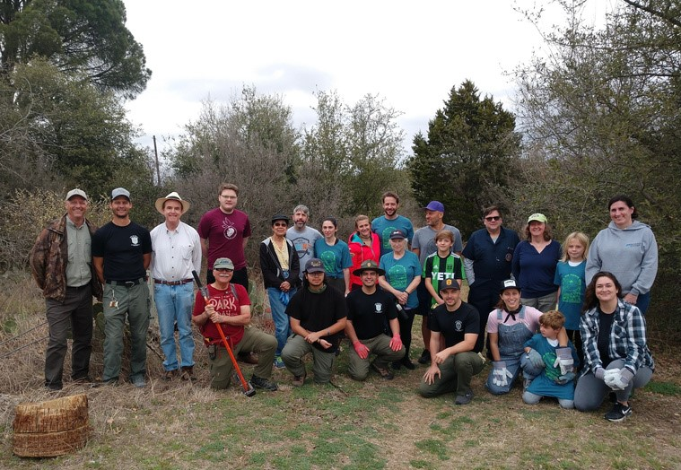

## Award for Historic District Team

For the preservation team’s efforts and because of the number of houses and the large variety of historic styles the neighborhood represents, Preservation Austin honored the Travis Heights-Fairview Park Historic District Team with the 2021 Special Recognition Award for Public Service. (See photo on pg.1)

## Neighborhood Listserv

Did you know our neighborhood has had its own listserv for over 25 years? Communicate with your neighbors about lost dogs, the best plumber, or even crime problems. Sign up for the IO Groups listserv by following these steps:

Go to groups.io/g/SouthRiverAustin and ask to join

7

Respond to an email you will get to verify your identity

Follow the prompts to join the IO Groups Listserv

If you have problems or questions, click on SouthRiverAustin+help@groups.io and ask for help

Lights Out, Austin!

Recently several SRCC neighbors shared information about how to protect birds during the spring migration (March 1-June 15). Since most birds migrate at night, they can become disoriented by light pollution, between 11pm-6am, especially during peak migration from April 22-May 12, so please

Turn off lights at night in unoccupied spaces

Close curtains and blinds

Turn off exterior floodlights during bird

migration season

Use shielded lighting that directs lights downward.

Be thoughtful and kind for the sake of our fine feathered friends!

## Neighborhood Watch

The Neighborhood Watch Program seeks volunteers. Patrolling the neighborhoods in SRCC areas would involve use of your own vehicle, with magnetic signs (that identify drivers as being on patrol) attached to vehicle doors. There are fairly specific written protocols for patrolling, which include emphasizing that volunteers are not the police. It is not a volunteer’s job to stop crime or criminals but to report suspicious activity by calling 311 or 911, as needed. Driving around the SRCC neighborhoods, showing the watch patrol signs, serves to remind those who see the patrols that we are out there watching. The Austin Police Department has provided valuable information describing useful measures to safeguard your home from burglary or when preparing to go on vacation. You may download those materials from the SRCC website: [srccatx.org/2022/03/30/apd-checklists/](http://www.srccatx.org/2022/03/30/apd-checklists/)

If you are interested in our neighborhood watch program, please contact me at tgroce71@gmail.com.

- Tom Groce

## South River City Citizens Meetings

3rd Tuesdays of most months starting at 7:00 p.m. See [srccatx.org](http://www.srccatx.org/) for details about how to attend.

We thank all of our officers, area coordinators, committees, and representatives for their dedication to our community! Contact your area coordinators for SRCC questions, volunteer opportunities, or to help out at a meeting.

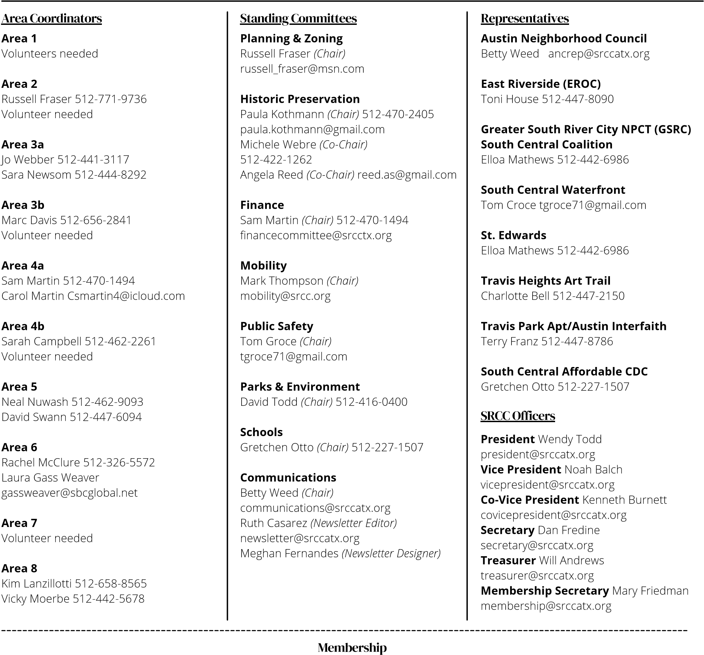

Become a member and be eligible to vote! Join or renew online at **srccatx.org**. To pay via PayPal, go to [srccatx.org/membership-dues/](http://www.srccatx.org/membership-dues/) or send a check made payable to SRCC, along with this completed form to:

**SRCC, Attention: Treasurer, P.O. Box 40632, Austin, TX. 78704**

Family memberships:provide names of each family member (adults residing at the same address). When paying via PayPal, include the names of family members in the Instructions to Merchant or Shipping Details areas.

Dues are not tax-deductible. If dues lapse, renew before a meeting and be eligible to vote. New members can vote after 28 days.

|  |  |  |
| --- | --- | --- |
|  | |  | | --- | | **Membership Levels**  **# Years Individual Family**   1. $20 $35 2. $35 $65 3. $50 $95 | |
| |  | | --- | | **Membership Fees Due: $______**  **Additional Donation to SRCC General Fund: $______**  **TOTAL: $______** | |

**Date**: ______________________________________________________________

**Name*(s)***: __________________________________________________________

______________________________________________________________________

**Address**: ___________________________________________________________

**SRCC Area *(see map)***: ______ **Phone(s)**: __________________________

**Email(s)**: ___________________________________________________________

**Number of years (circle one)**: 1 2 3

**Membership (circle one)**: Individual Family